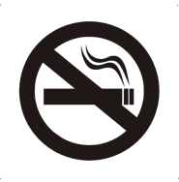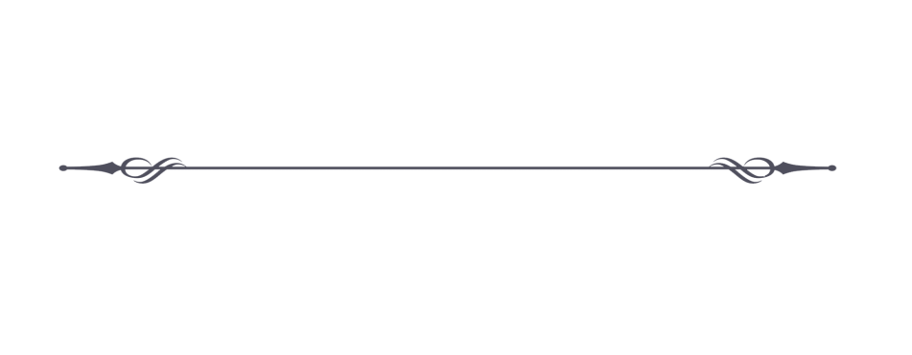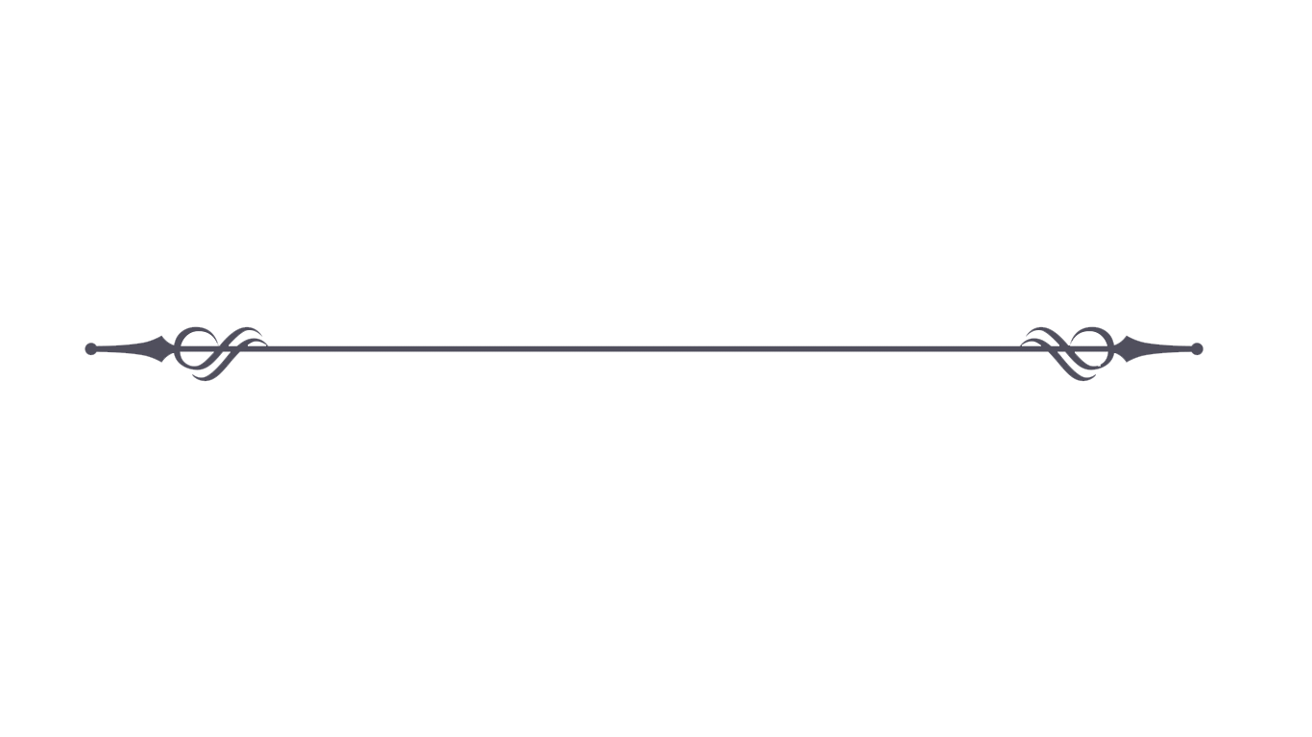

Informations for quests

* Check-in: after 02:00 p.m. – 10:00 p.m.
* Check-out: before 10:00 a.m.
* For each apartment are available:

coffee - pot + 2 coffee cups with spoons,

TV (57 channels),

internet: Wi-Fi - free,

fridge,

telephone (reception number 11).

* Wi-Fi: Resla Residence, **password: 12345678**

**Breakfast**

* Breakfast: 8:00 a.m. – 10:00 a.m. in Resla Residence I. Price is 7,00 € per person.

**Wellness and fitness**

* Fitness is free and is located in Resla Residence II.

Wellness jacuzzi and sauna are for fee and it is located in Resla Residence II.

* All apartmens are non smoking!
* Opening hours: monday to sunday: 08:00 - 22:00.
* Responsible manager: PhDr. Dávid Ivan

Dolná Resla 2, 969 01 Banská Štiavnica. Phone: +421 918 802 995